Game Design Document
In the dark
Helldivers

Team Members
Name | Roles | E-mail & GitHub ID
Xiufang Chen | Captain, Level Designer | xiufangc@usc.edu  repoRookie
Samarth Narahari Mandagere | Level Designer, Playtester | mandager@usc.edu  MNSamarth
Saiom Pal | Hud designer, Level Designer | saiompal@usc.edu  saiompal
Xiangyu Zhao | Analytics, Stenographer | xzhao000@usc.edu  Fkiness
Zerui Lyu | Product Manager, Physics | zeruilyu@usc.edu  Harry58326

Game Introduction

Logline
A maze puzzle platformer where players memorize paths before darkness falls, use limited flashes of light, and navigate a periodically flipping world to collect every star and reach the exit.

Player Goals / Win Conditions
Collect all the stars
Reach the exit
Clear all levels

Game Description
Players explore a dark maze, collect every star, and find the hidden exit to complete each level. Before the lights go out, players can study the level layout and memorize routes and star locations. Once darkness falls, only a small circle around the player remains visible. Pressing F briefly illuminates the entire level, but charges are limited, requiring players to decide when to refresh their memory or check their surroundings.
Every few seconds, the world flips upside down while gravity continues pulling downward, changing which surfaces players can stand on and which routes they can access. The player’s light pulses red before each flip, giving them time to prepare. Players must combine movement, jumping, route memory, and careful use of light to navigate the changing maze. The hidden exit remains locked until every star has been collected.

Controls
Movement: A, D
Jump: Space
Light the map: F
Restart: R

Detailed Design

Game Mechanics (How to Play)
Movement and Jumping: Press A/D to move left or right and SPACE to jump. Players use these actions to navigate corridors, cross gaps, and reach stars.
Level Memorization: At the beginning of each level, the entire maze is briefly visible. Players can memorize routes, star locations, and the level layout before the lights go out.
Limited Visibility: Once darkness falls, players can only see a small circle around their character. They must combine local visual information with their memory to navigate the maze.
Limited Light Charges: Press F to briefly illuminate the entire level. Charges are limited, so players must choose when to reveal the maze to check their position, plan a route, or locate remaining stars.
Automatic World Flips: Every few seconds, the world flips upside down while gravity continues pulling downward. This changes the orientation of platforms and obstacles, making different routes accessible.
Star Collection: Players collect stars by touching them. Every star in the level must be collected to unlock the exit.

Game Mechanic Research
<Limited Visibility and Maze Exploration>
Game Title | Super Mario Maker 2 — Nighttime Ghost House Courses
Mechanic/System | Limited visibility
Interest | Limited visibility makes players explore cautiously because they cannot see the entire route ahead. This is relevant to our game’s small light circle, which restricts the information available while navigating the maze.
Interaction with other mechanics | Darkness interacts with movement, jumping, and level obstacles. Players must approach unfamiliar areas before they can clearly judge platform positions and decide how to proceed.
Innovation | Our game combines limited visibility with an initial opportunity to memorize the level. Players must use that memory to locate stars and navigate after the lights go out. Periodic world flips add another challenge by requiring players to reinterpret the layout as its orientation changes.

<Limited Lighting Resources>
Game Title | Amnesia: The Dark Descent
Mechanic/System | Resource-based illumination
Interest | Making illumination a limited resource turns visibility into a decision. Players must consider when additional information is worth spending a resource, rather than keeping their surroundings illuminated continuously.
Interaction with other mechanics | Lighting interacts with exploration, resource collection, and sanity management. Players search for supplies to maintain access to light, while extended exposure to darkness reduces the character’s sanity.
Innovation | Our game uses limited charges that briefly reveal the entire level instead of a continuously powered lantern. Each flash gives players a short opportunity to check routes and locate remaining stars. Combining these flashes with world flips makes the timing of illumination important for updating the player’s mental map.

<World Rotation and Route Changes>
Game Title | And Yet It Moves
Mechanic/System | World rotation
Interest | Rotation makes the same geometry serve different purposes. A surface that blocks progress in one orientation can become part of a usable route in another, encouraging players to think beyond the level’s current arrangement.
Interaction with other mechanics | World rotation interacts with running, jumping, and physics. Changing the environment’s orientation alters how the character and loose objects move, allowing players to solve traversal puzzles.
Innovation | Our world flips upside down automatically every few seconds while gravity continues pulling downward. Players must anticipate these changes rather than trigger them freely. A red pulse in the player’s light warns of an approaching flip, allowing preparation even when most of the maze is hidden.

<Collecting All Items Before Progression>
Game Title | PAC-MAN
Mechanic/System | Collection-based level completion
Interest | Requiring complete collection encourages players to explore the entire maze. Route planning matters because reaching one destination is insufficient; players must also account for items left in other branches.
Interaction with other mechanics | Collection interacts with maze navigation and ghost avoidance. Players choose routes that clear remaining dots while avoiding enemies, and Power Pellets temporarily allow them to eat ghosts.
Innovation | Our game requires players to collect every star before the hidden exit unlocks. Darkness makes remembering unexplored paths and remaining star locations important, while world flips change how players reach them. After collecting all stars, players must still locate and reach the exit to complete the level.

<Timed Environment Changes>
Game Title | Super Mario 3D World — Beep Block
Mechanic/System | Timed platform switching
Interest | Requiring complete collection encourages players to explore the entire maze. Route planning matters because reaching one destination is insufficient; players must also account for items left in other branches.
Interaction with other mechanics | Collection interacts with maze navigation and ghost avoidance. Players choose routes that clear remaining dots while avoiding enemies, and Power Pellets temporarily allow them to eat ghosts.
Innovation | Our game requires players to collect every star before the hidden exit unlocks. Darkness makes remembering unexplored paths and remaining star locations important, while world flips change how players reach them. After collecting all stars, players must still locate and reach the exit to complete the level.

Matrices

Twist & Mechanics Matrix
Mechanics | Description | Interaction with Twist | Affected Genre Elements | Supports
Limited Visibility and Memorization | Players study the level before darkness falls. Afterward, only a small circle around the character remains visible. | Players must remember routes and reinterpret the memorized layout after each world flip. | Exploration, spatial memory, route planning | Player movement, star collection, exit finding
Automatic World Flips | The world flips upside down every few seconds while gravity continues pulling downward. A red light pulse warns players before each flip. | Flips change which surfaces support the player and which routes are accessible, requiring preparation with limited visibility. | Platforming, timing, spatial reasoning | Player movement, access to stars and the exit
Player Movement and Jumping | Players move left or right with A/D and jump with SPACE to traverse the maze. | Players navigate within a small visible area and time their actions around upcoming world flips. | Traversal, jump timing, positioning | Maze exploration, star collection, reaching the exit
Star Collection and Exit Unlocking | Players must collect every star before the hidden exit unlocks, then reach it to complete the level. | Players must explore multiple routes in darkness and use different world orientations to reach objectives. | Collection, exploration, level completion | Route planning, memorization, use of light charges

Mechanic Interaction Matrix
Subject / Object | Limited Visibility and Memorization | Automatic World Flips | Movement and Jumping | Star Collection and Exit Unlocking
Limited Visibility and Memorization

Automatic World Flips | Players must mentally update the memorized layout after each flip. The red pulse warns of a change even when most of the maze is hidden.
Movement and Jumping | Players use nearby visual information and remembered geometry to choose directions and judge jumps. | Flips change supporting surfaces and reachable paths. Players adjust their position and jump timing before the environment changes.
Star Collection and Exit Unlocking | Players remember star locations and explored branches while searching for the hidden exit. | Different orientations change the routes available for reaching stars and the exit. | Players traverse corridors and jump to reach stars, then navigate to the exit after collecting them all.

Sketches and Diagrams

Gameplay Loop
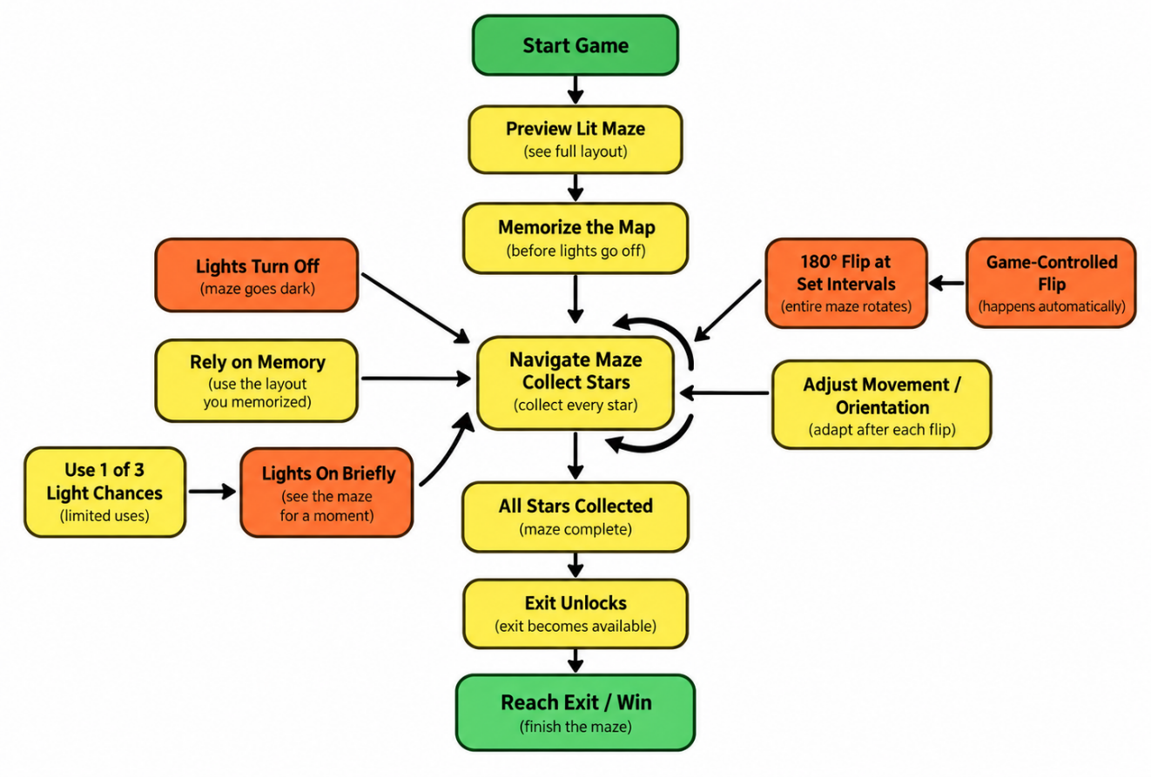

Mechanic/Level Sketches
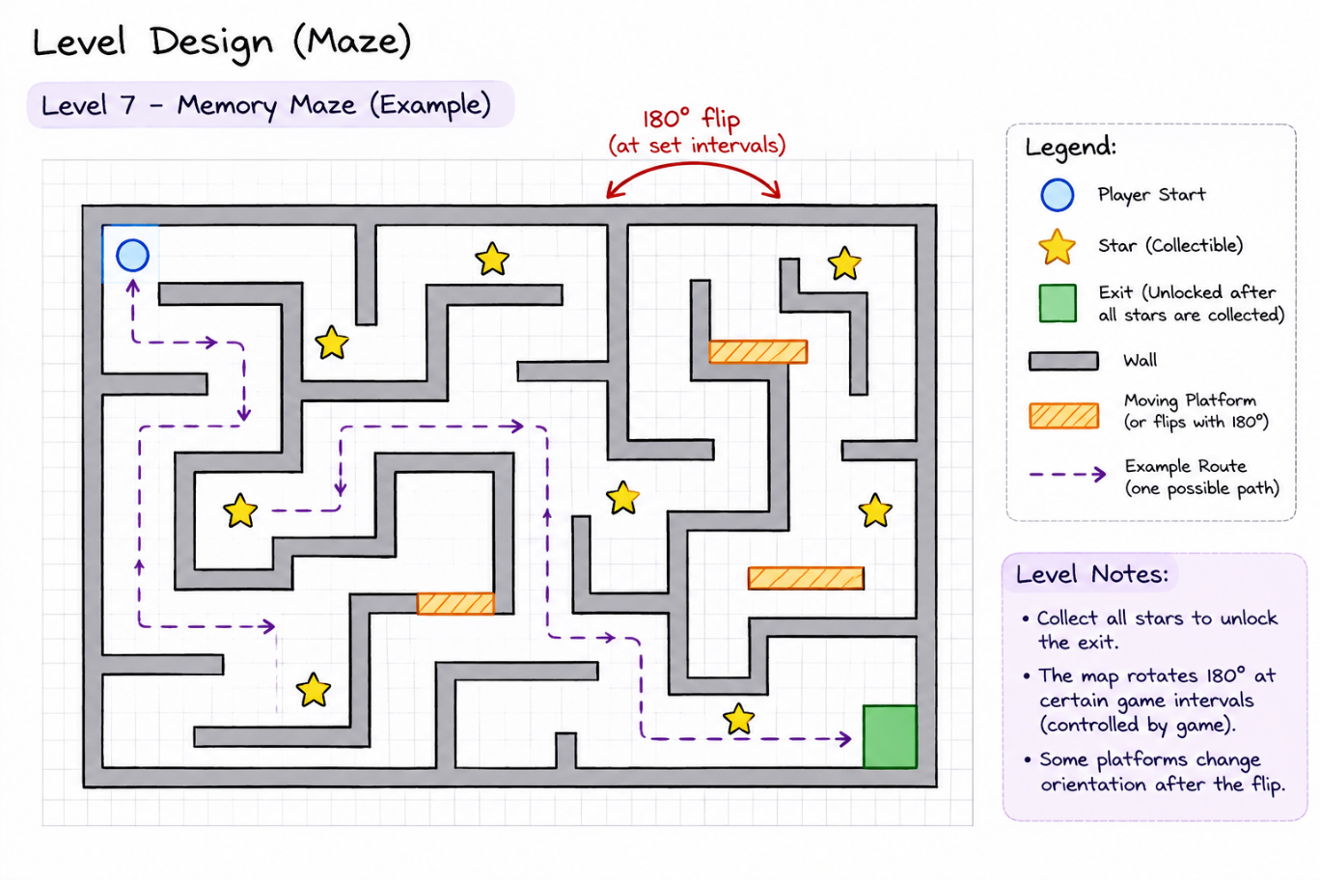

Weekly Prototype Descriptions
Describe each of your weekly prototypes here, noting additions, changes, and improvements. It is important to keep this updated every week. Add a few screenshots from each week's development.

Week-8:
- Added an initial view of the entire level so players can memorize its layout before the lights go out. During exploration, visibility is restricted to a small circle around the character.
- Implemented the F ability to briefly illuminate the entire maze. Limited charges require players to choose when to check routes and refresh their memory.

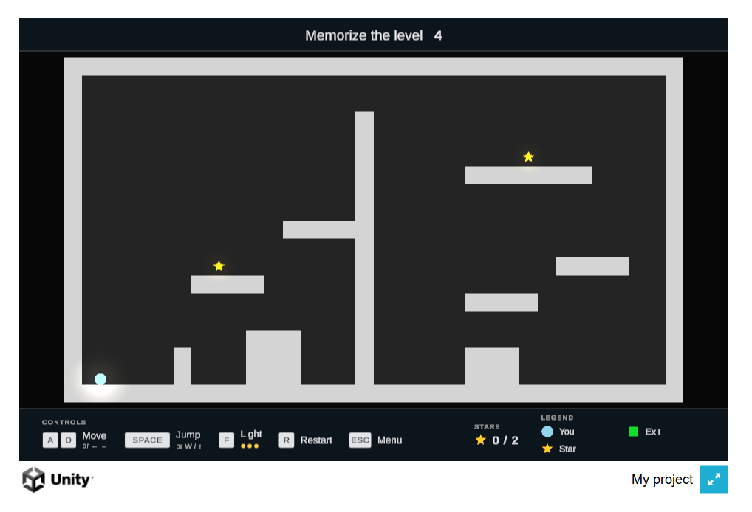

Week-9:
- Added periodic upside-down flips while gravity continues pulling downward, changing accessible routes and supporting surfaces.
- Added a red pulse to the player’s light before each flip, giving players time to prepare.
- Added multiple levels with different maze layouts, platform arrangements, and star locations.
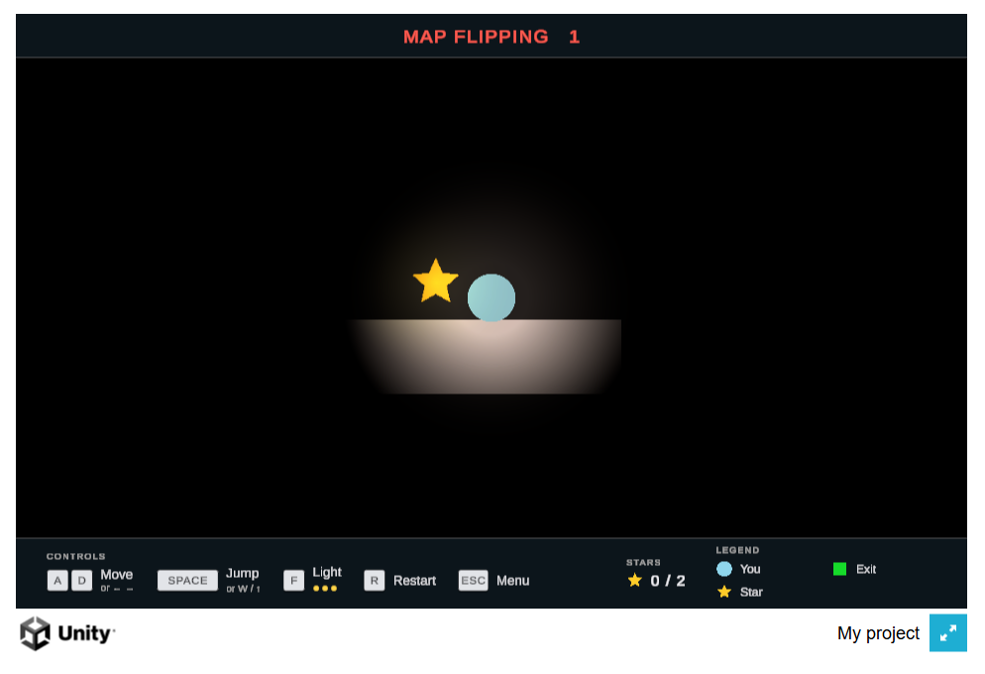

Weekly Progress
List the individual work done by each team member up to that week in the table below. Add short descriptions of the work done and add a link to one relevant Github commit for the respective work done by that team member.

Week Number | Team Member
Week 8 | Xiufang Chen | Samarth Mandagere
Week 8 | Concept Art research, game flow diagram, and level sketches. | Design Planning, Integration
Week 8 | Saiom Pal | Xiangyu Zhao
Week 8 | Game mechanic  Main Menu, HUD | Data Collection
Week 8 | Zerui Lyu
Week 8 | systems
Week 9 | Xiufang Chen | Samarth Mandagere
Week 9 | Level Design Commit Link | Level Design and Playtesting  Commit Link
Week 9 | Saiom Pal | Xiangyu Zhao
Week 9 | Initial build, camera system refinement, Commit Link | Bug testing, GDD writing
Week 9 | Zerui Lyu
Week 9 | gameplay
Note: This is to be followed for the rest of the semester. Make sure it is updated each week.

